Accounts Payable Process

Microsoft Dynamics 365 Finance & Operations (M365)

AP Group :
Team leader: Amira Allam
Group members: Mohamed khairy
Sohila Ashraf
Maria Bassem

Step 1: Open the Accounts Payable Module

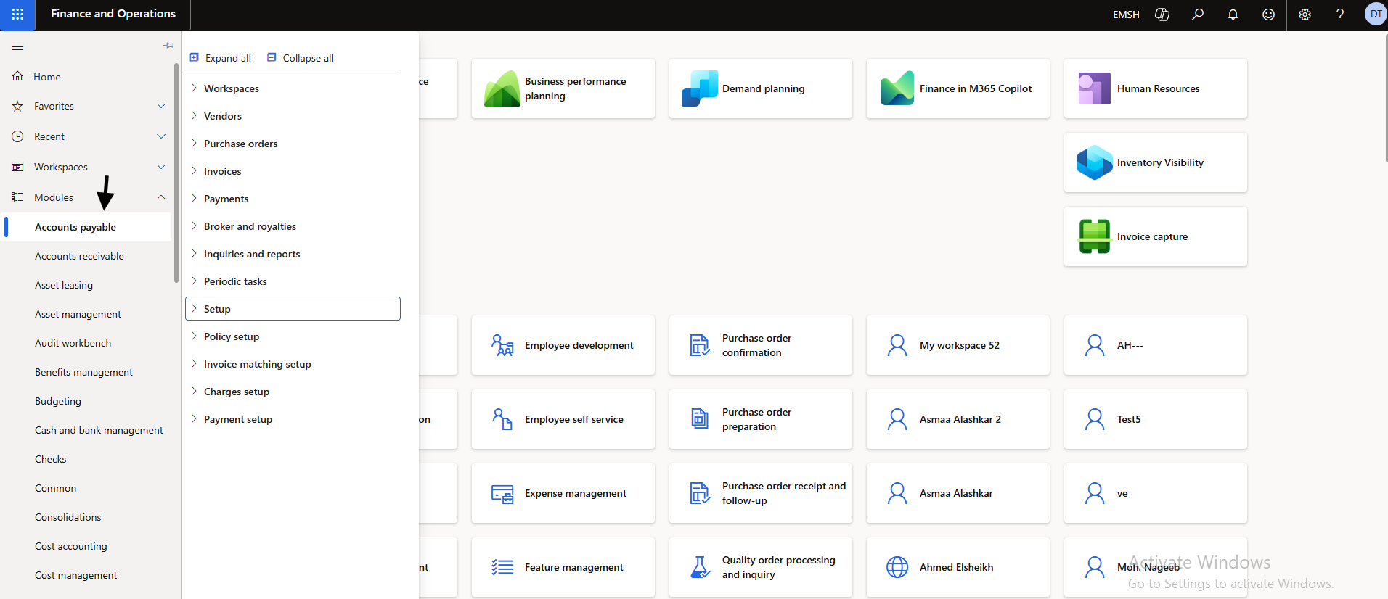

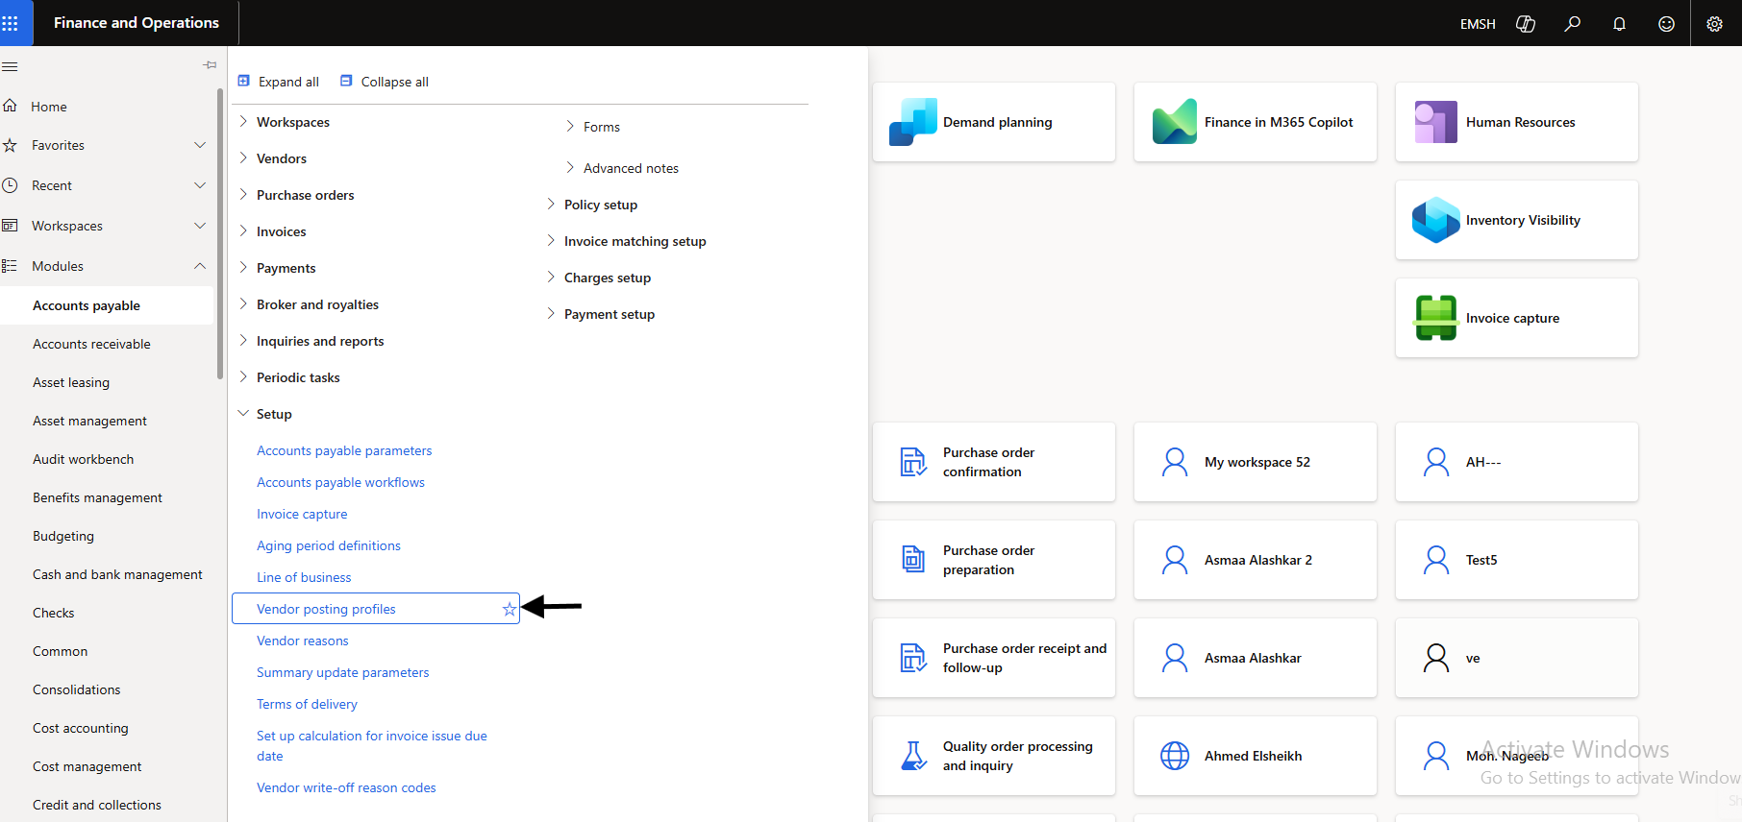

- Log in to Microsoft Dynamics 365 Finance and Operations.
- From the left navigation menu, click Modules.
- Select Accounts payable.
* This module contains all functions related to vendor management, invoices, payments, and reporting.

Step 2: Access the Setup Menu

- Inside Accounts payable, locate the menu options.
- Click Setup to configure Accounts Payable settings.
The setup section allows users to configure vendor parameters, posting profiles, and system rules.

Navigate to Vendor Posting Profiles:

In Microsoft Dynamics 365 Finance & Operations, follow these steps:
- From the left navigation menu, click Modules.
- Select Accounts payable.
- Click Setup.
- From the list of setup options, select Vendor posting profiles.
* The Vendor Posting Profile is used to define the ledger accounts that will be used for vendor transactions, such as vendor invoices and payments.

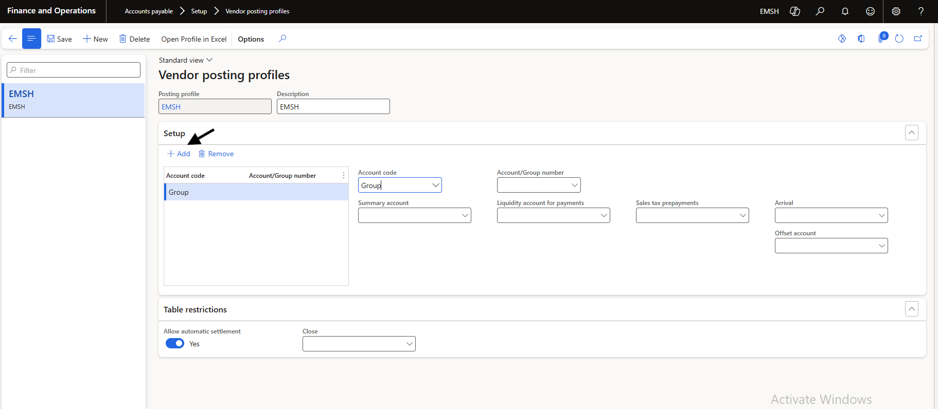

After selecting Vendor posting profiles, the system will open the configuration page.
Here you can:
- Create new posting profiles
- Define accounts used for vendor transactions
- Assign accounts based on vendor groups or specific vendors
Step 3: Configure Vendor Information

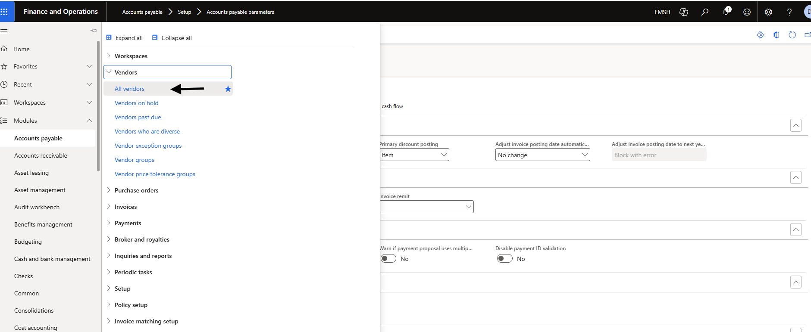

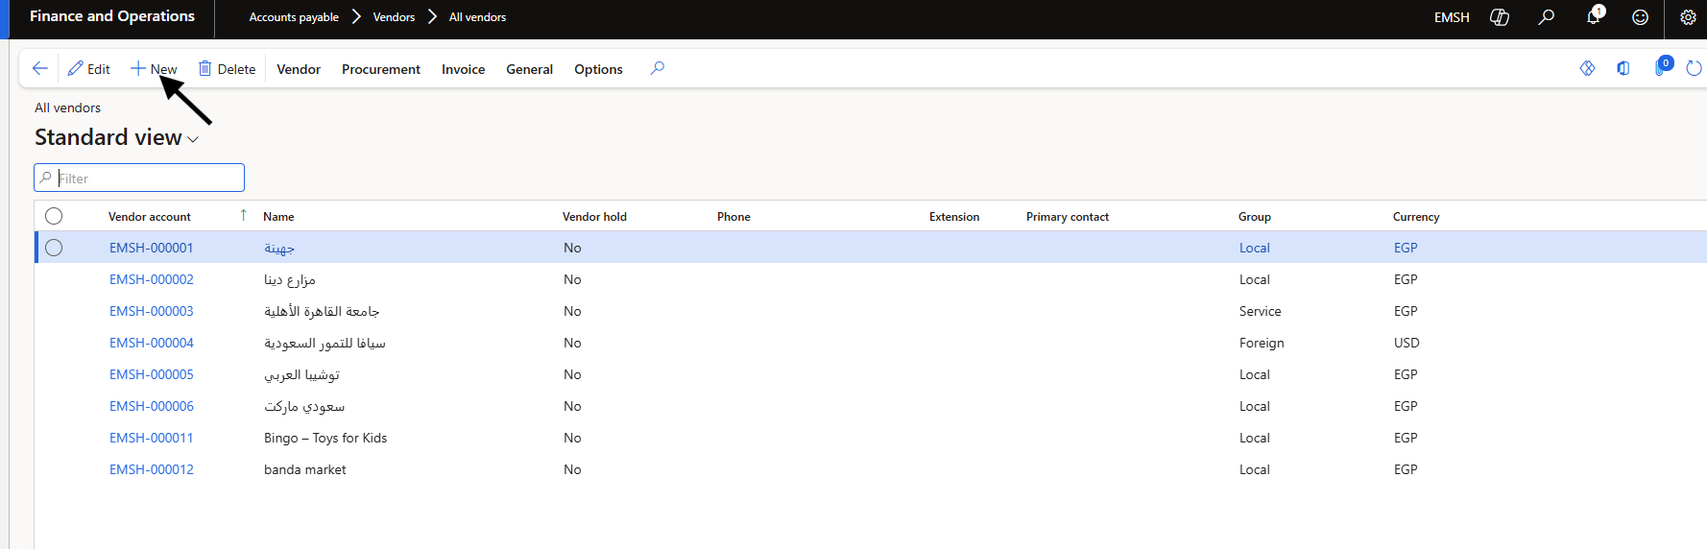

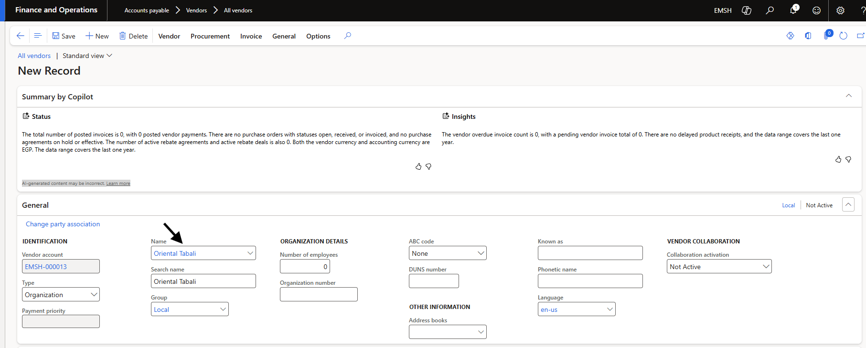

- Navigate to Vendors.
- Select All Vendors.
- Click New to create a vendor account.
Fill in the required information such as:
- Vendor account number
- Vendor name
- Vendor group
- Address and contact information
- Payment terms
Click Save after entering the details.

Step 4 :Navigate to Journal Names & Select or Create the Vendor Invoice Journal:

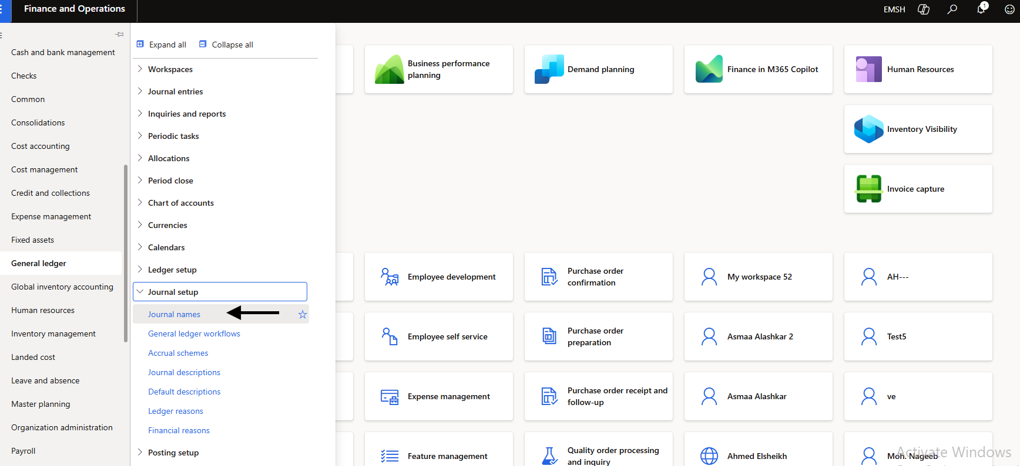

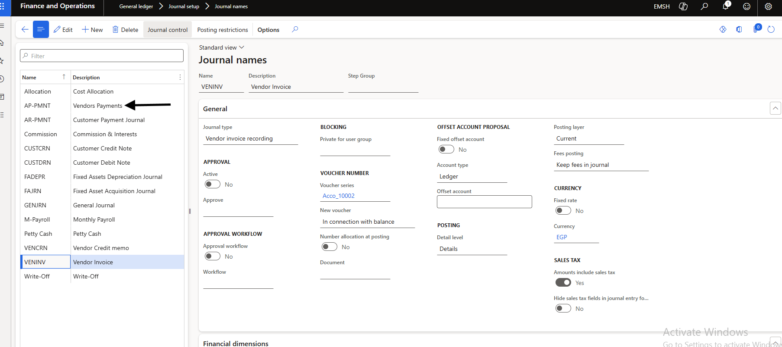

First, you need to access the Journal setup section in the system.
Procedure:
- Go to Finance and Operations.
- From the left navigation menu, select General Ledger.
- Click Journal setup.
- Select Journal names.
This section allows you to create and manage different types of journals used in the system.

In the Journal Names page, you will see a list of available journal types.
Procedure:
- Locate the journal named VENINV.
- The Description should display Vendor Invoice.
- Select this journal to review or modify its settings.
This journal is used specifically for recording vendor invoices in Accounts Payable.

Step 5 Recording an Accounts Payable Invoice Using Invoice Journal:

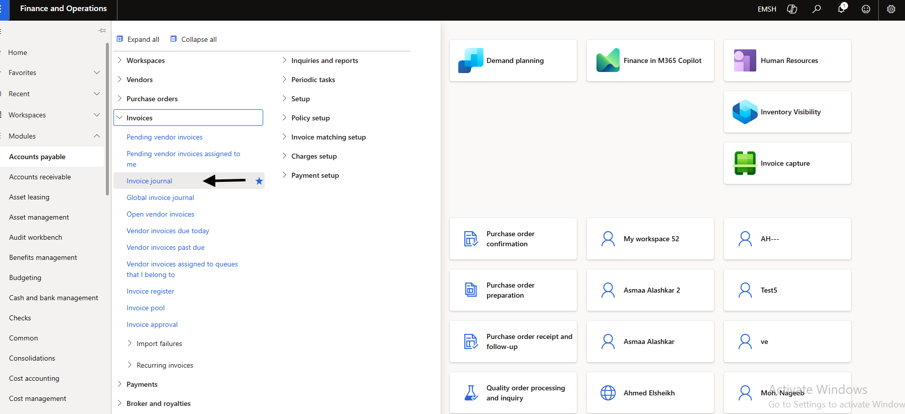

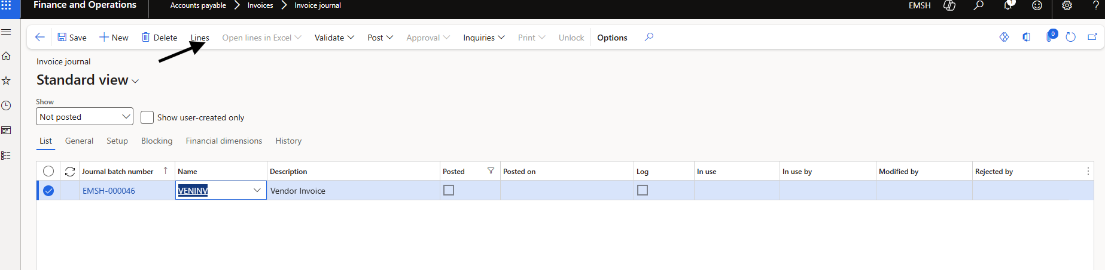
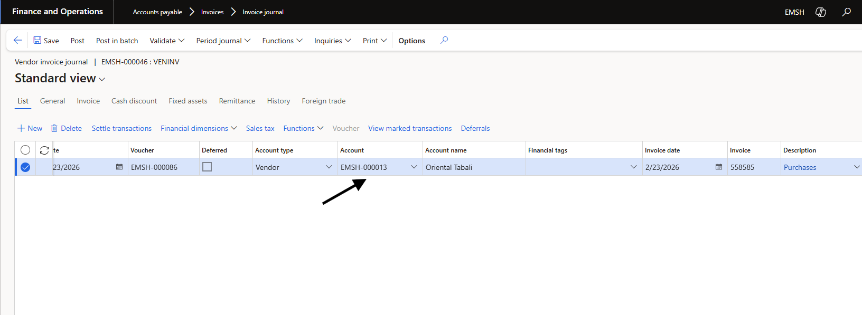
Navigate to Invoice Journal
To record a vendor invoice, you need to open the Invoice Journal in the Accounts Payable module.
Procedure:
- Go to Accounts payable from the left navigation menu.
- Click Invoices.
- Select Invoice journal.
This page allows users to create and manage vendor invoice journals for posting Accounts Payable transactions.

Create a New Invoice Journal
Once the Invoice Journal page opens, you can create a new journal batch.
Procedure:
- Click New at the top of the page.
- A new journal batch will be created.
- In the Name field, select VENINV – Vendor Invoice.
This journal batch will contain the vendor invoice transactions to be recorded.

Enter Vendor Invoice Details
After creating the journal batch, open the journal lines to enter the invoice details.
Procedure:
- Click Lines to open the journal entry lines.
- Enter the following information:
- Account Type: Vendor
- Account: Select the vendor account (example: EMSH-000013 – Oriental Tabali).
- Invoice Date: Enter the vendor invoice date.
- Invoice Number: Enter the invoice number provided by the vendor.
- Description: Add a short description (example: Purchases).
These fields record the vendor invoice and link it to the correct supplier account.

Validate and Post the Journal
After entering all invoice details:
- Click Validate to check for any errors.
- Click Post to finalize and post the vendor invoice to the ledger.
Once posted, the system records:
- The Accounts Payable liability
- The corresponding expense or purchase account
Processing Vendor Payment

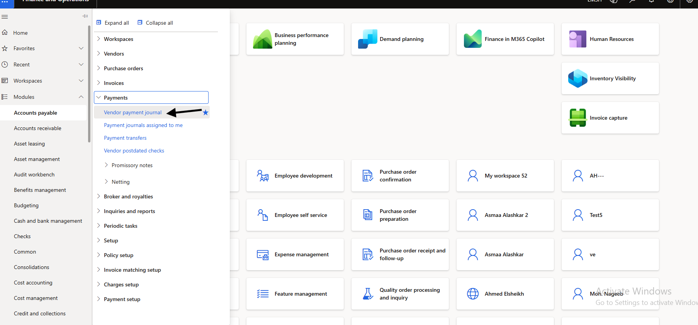
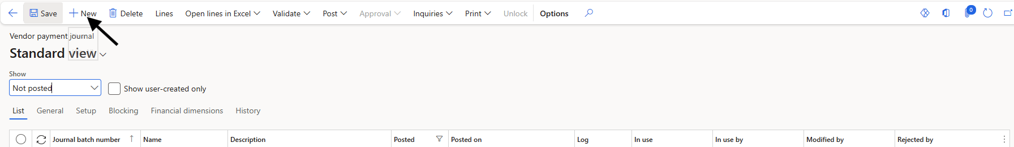

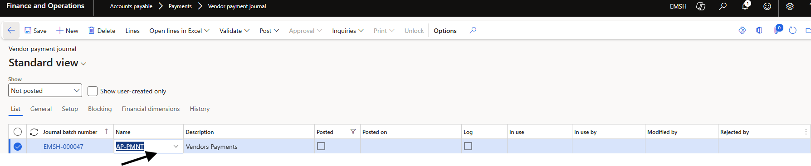
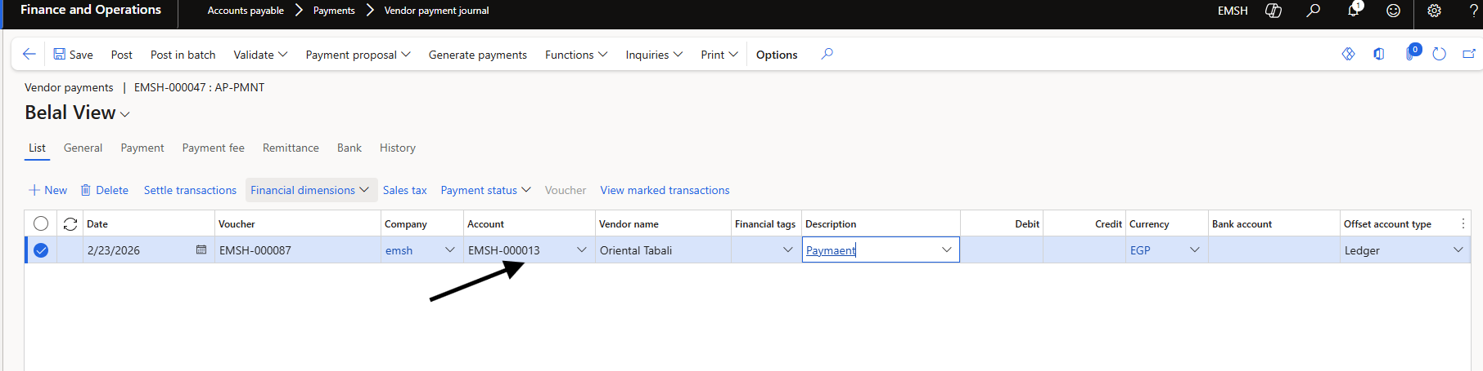

Step 6 Navigate to Vendor Payment Journal
After recording the vendor invoice, the next step is to process the payment.
Procedure:
- Go to Accounts payable.
- Click Payments.
- Select Vendor payment journal.
This section is used to create and manage vendor payment transactions.

Step 7: Create a New Payment Journal
Once the Vendor Payment Journal page opens, create a new journal batch.
Procedure:
- Click New.
- A new journal batch will be created for vendor payments.
This journal will contain the payment entries for vendors.

Step 8: Enter Payment Details
After creating the journal, open the Lines section to enter payment information.
Enter the following details:
- Date: Payment date
- Account: Select the vendor account
- Vendor Name: Automatically appears after selecting the vendor
- Description: Payment
- Currency: EGP
- Debit Amount: Enter the payment amount

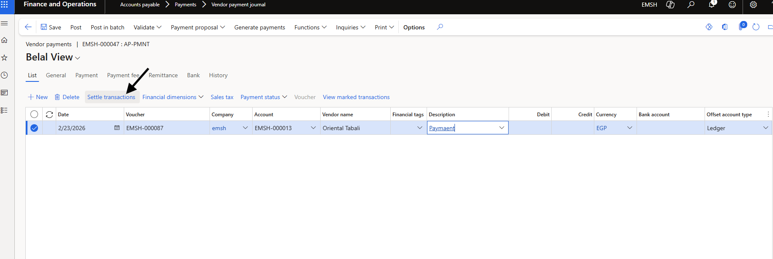

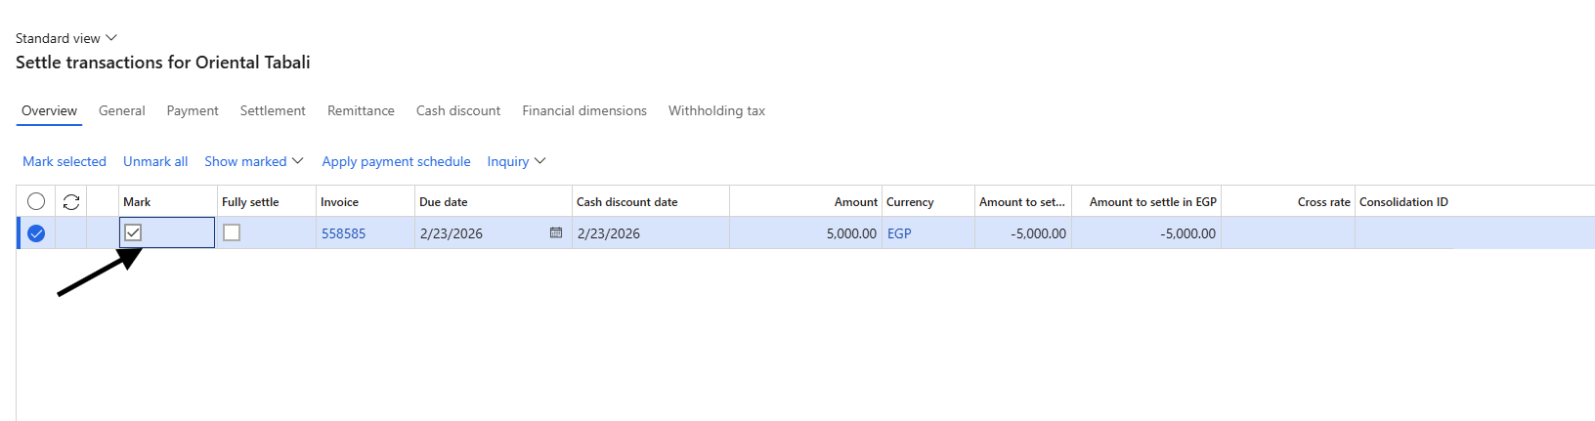
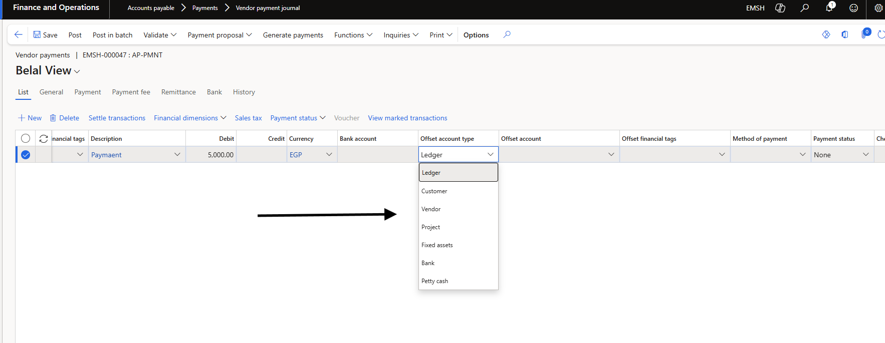
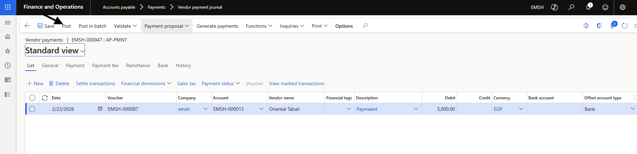
Step 9: Settle the Vendor Invoice
To link the payment with the vendor invoice:
Procedure:
- Click Settle transactions.
- A list of outstanding invoices for the selected vendor will appear.
- Check the Mark box next to the invoice you want to pay.
This step ensures the payment is applied to the correct vendor invoice.

Step 10: Select the Offset Account
The offset account determines where the payment will be deducted from.
Procedure:
- In Offset account type, select Bank.
- Choose the appropriate Bank account.
Other possible offset account types include:
- Ledger
- Customer
- Vendor
- Project
- Fixed assets
- Petty cash

Step 11: Post the Payment Journal
After completing the payment details:
- Click Save.
- Click Post.
The system will record the payment and update the vendor balance.

Step 12: Verify Vendor Transactions

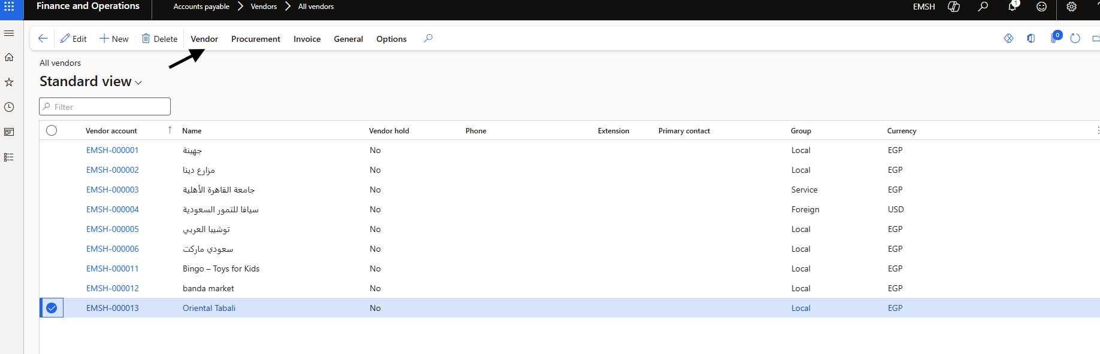

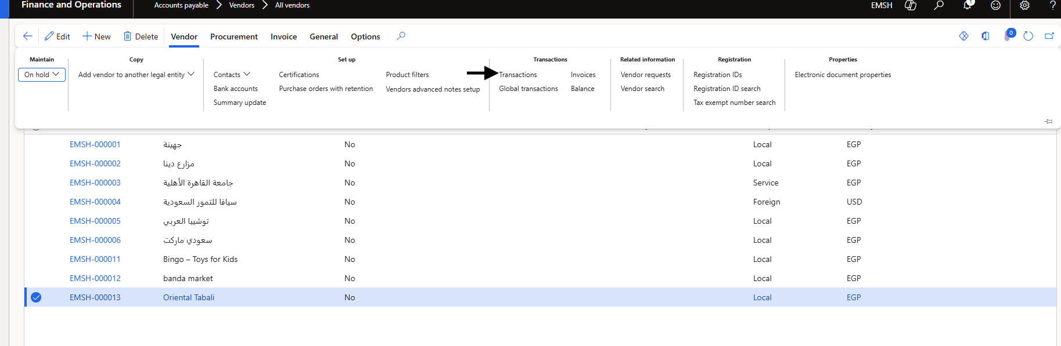

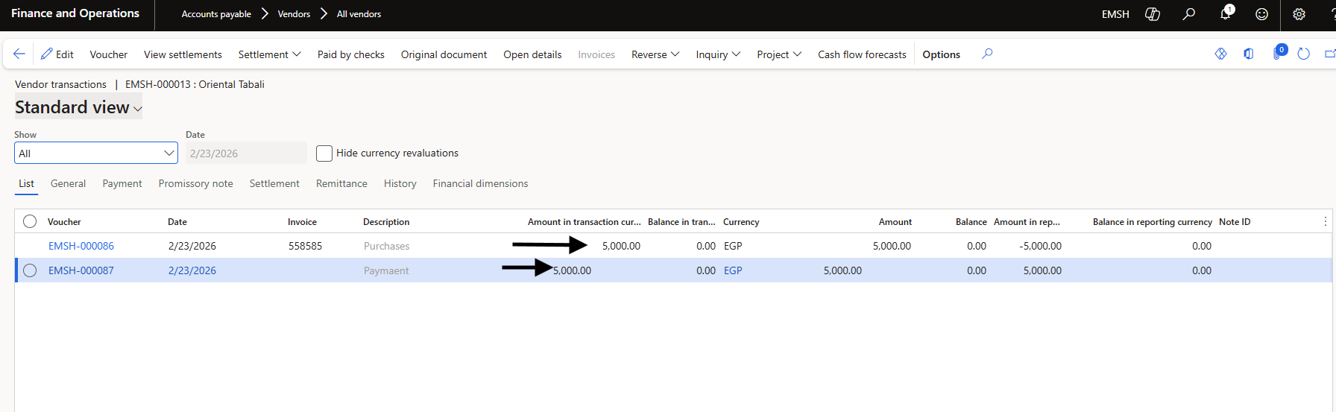

To confirm that the payment has been applied:
Procedure:
- Go to Accounts payable.
- Select Vendors.
- Click All vendors.
- Select the vendor account.
- Click Transactions.
You will see:
- The Vendor Invoice
- The Payment Transaction
Both entries should show that the invoice has been settled.

